**Steady State Error Analysis using Simulink**

**Lab report #09**



Fall 2022

CSE-310L Control Systems

Submitted by: **Ashfaq Ahmad**

Registration No: **19PWCSE1795**

Class Section: **B**

“On my honor, as student of University of Engineering and Technology, I have neither given nor received unauthorized assistance on this academic work.”

Student Signature: ______________

Submitted to:

**Dr: Muniba Ashfaq**

**January** 11, 2023

**Department of Computer Systems Engineering**

**University of Engineering and Technology, Peshawar**

**TASK:**

**Setup negative feedback system for the following system:**

**G(s) = k(s+6) / (s+4) (s+7) (s+9) (s+12)**

**H(s) = 1**

**Plot on one graph the error signal for….**

1. **Input = 5u(t) with k = 5,10,50,500,5000**

**Simulink:**

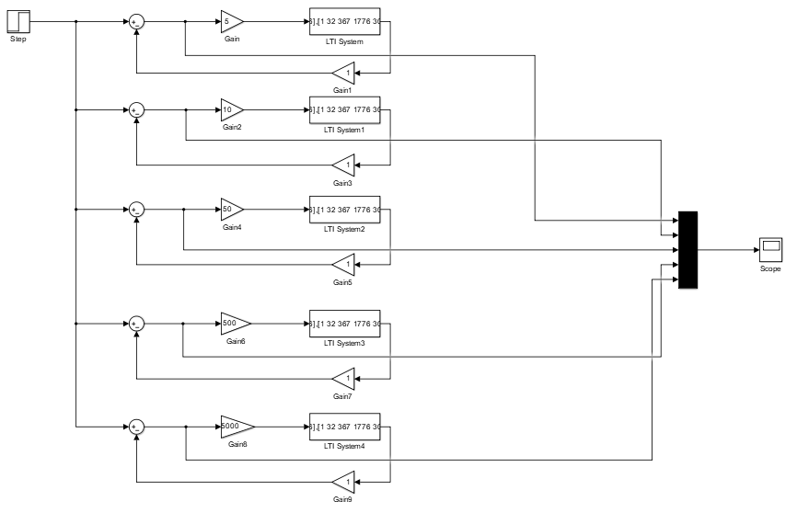

**Output:**

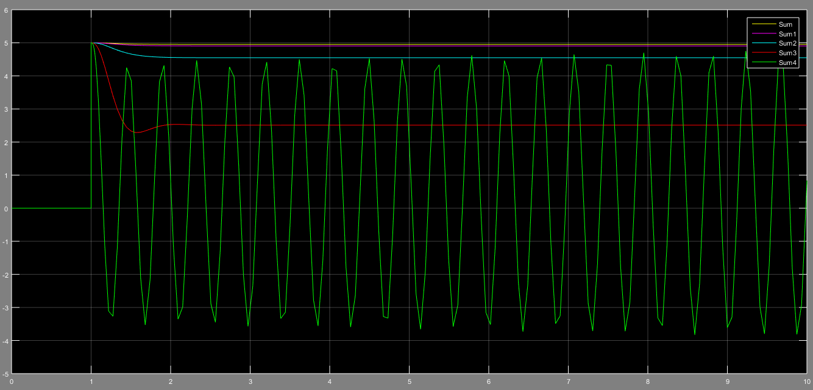

1. **Input = 5tu(t) with k = 5,10,50,500,5000**

**Simulink:**

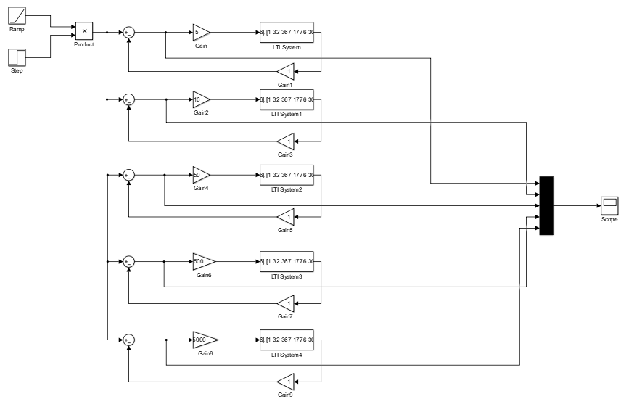

**Output:**

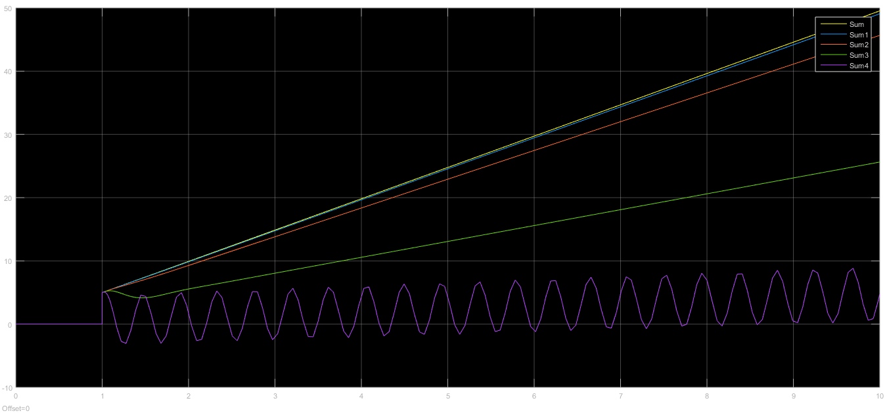

1. **Input = 5t^2u(t) with k = 5,10,50,500,5000**

**Simulink:**

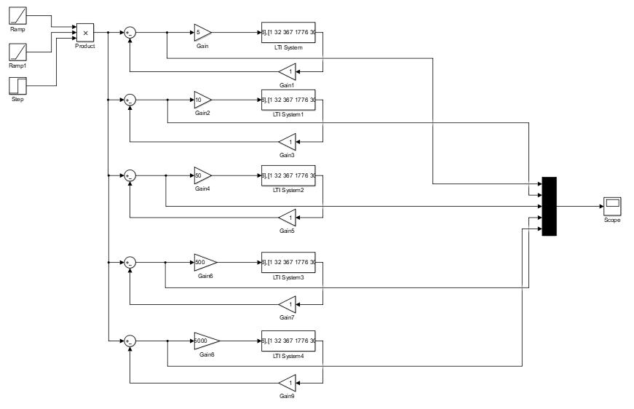

**Output:**

